**Project 2 (cwru-cle-data-pt-07-2020-u-c)**

**Group 3 Members: Brendan Rhoads, Even Kamis, Roshini Jayantha, Kimberly Gore**

**Proposal (topic and rationale):**

**The 2020 Election and Covid-19 Cases and Deaths**

Is there a relationship among states that voted for Biden/Trump and COVID cases and deaths?

Is there a relationship between a state’s unemployment rate and how these states voted?

Is there a relationship between a state’s unemployment rates and number of COVID cases and deaths?

**Links for data sets and screenshots of metadata (if exists):**

https://www.kaggle.com/etsc9287/2020-general-election-polls

https://www.bls.gov/web/laus/laumstrk.htm

https://github.com/zeke/us-counties

**3 or 4 screenshots of relevant, “inspiring” visualizations that frame your created fodder:**

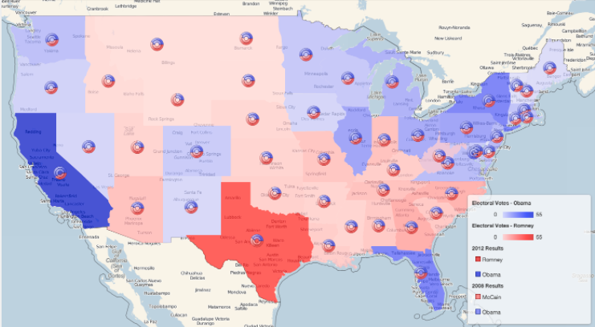 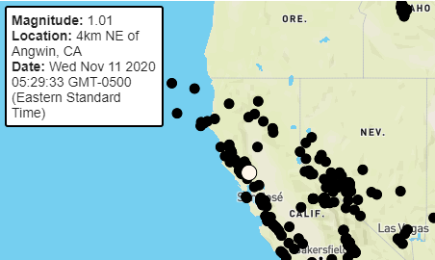 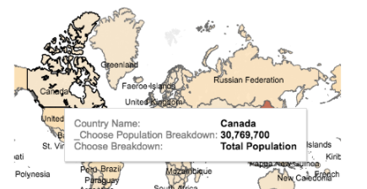 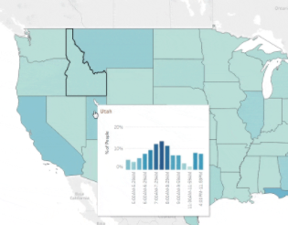

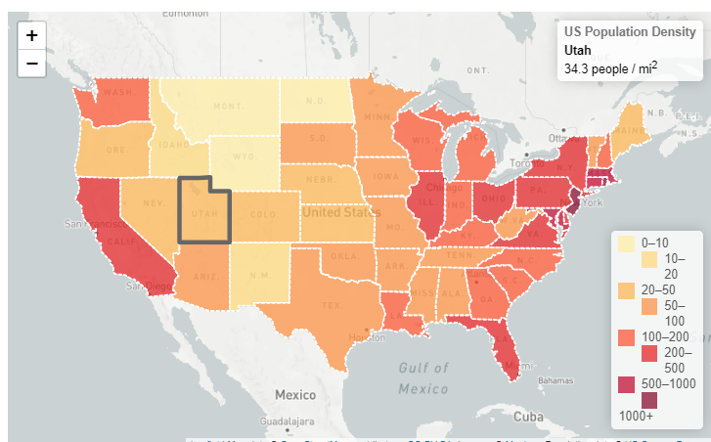 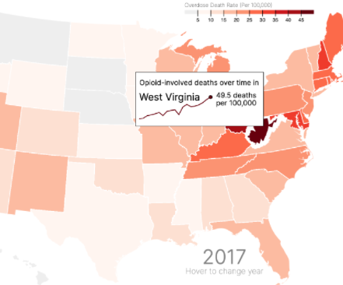 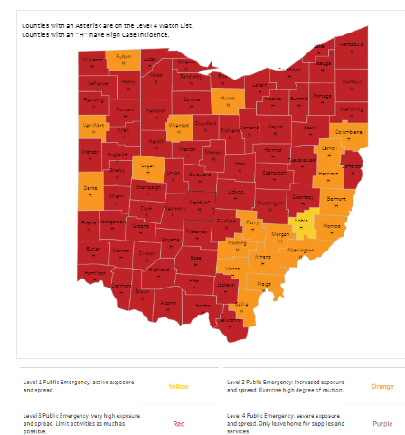

https://www.tableau.com/about/blog/2017/11/viz-tooltip-here-78442

https://docs.mapbox.com/help/tutorials/create-interactive-hover-effects-with-mapbox-gl-js/

https://www.connorrothschild.com/post/adding-a-chart-to-your-d3-tooltip/

https://academy.datawrapper.de/article/116-how-to-create-useful-tooltips-for-your-maps

https://leafletjs.com/examples/choropleth/

https://github.com/plotly/plotly.js/issues/1847

https://docs.mapbox.com/mapbox-gl-js/example/hover-styles/

**Sketch of the final design:**

* Page one (by state): Layer 1 - Presidential Election // Layer 2 – COVID Cases by % scale // Layer 3 – Income Level?   
  ***with a dropdown menu on the left
* Page two

**Link for primary Github repository:**

https://github.com/KGore12/Group_Project_2

**What will you use?**

AWS or Heroku

**Who is responsible for what section of the project?**

* ETL Process  
  Find Data-sources  
  Transform Data-cleaning, joining, filtering, aggregating, etc.  
  Type of final production database to load data  
  Final Tables or collections
* Create the interactive maps
* Design the webpage

**Specific Project requirements:**

**What are we using?**

Python Flask – powered API, HTML/CSS, JavaScript, and at least one database (PostGreSQL, MongoDB)

**Which track?**

* Custom “creative” D3.js project (i.e. nonstandard graph or chart)
* Combination of web scraping and Leaflet or Plotly
* Dashboard page with multiple charts that update from the same data

**Is the project powered by a dataset with at least 100 records?**

**What user-driven interactions are included and contained in the JavaScript itself?**

* Menus
* Dropdowns
* Textboxes

**Must include a menu-based system with a team page.**

**Is the project accessible via the web?**

**Does the visualization contain at least three views? (complex multifaceted graphs or maps)**

**Additional Considerations:**

1. Web page should be self-sufficient for the class
2. Deployed to web with either AWS or Heroku
3. Visualizations provide contextual clues for the greatest clarity
4. Bonus points for correct ETL process (no CSV file uploads to DB and DB loaded via automation or a user-controlled Flask route)
5. Ideal projects will share the web visualization at the beginning of the presentation
6. Ideal project will utilize the web visualization to within the presentation and use statistical analysis to further justify points in discussion. (This analysis and the how should be included as part of the web application as an additional page.)
7. Presentations last no more than 10 minutes and everyone speaks.
8. Code should be organized in a logical fashion that improves understanding. (example: data separate from code, Flask separated from client-side files)